The Distance to the Virgo Cluster

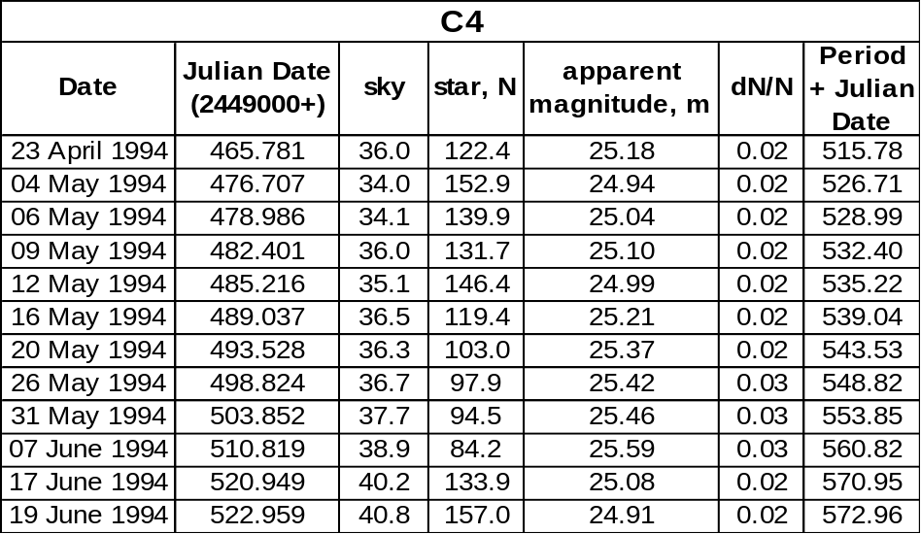

Mean star count = 123.60
Mean apparent magnitude = 25.17m

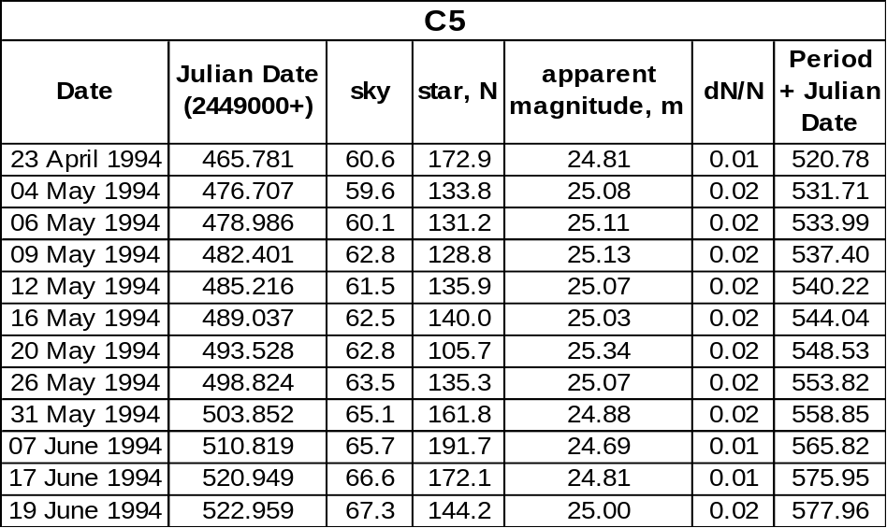

Mean star count = 146.12
Mean apparent magnitude = 24.99m

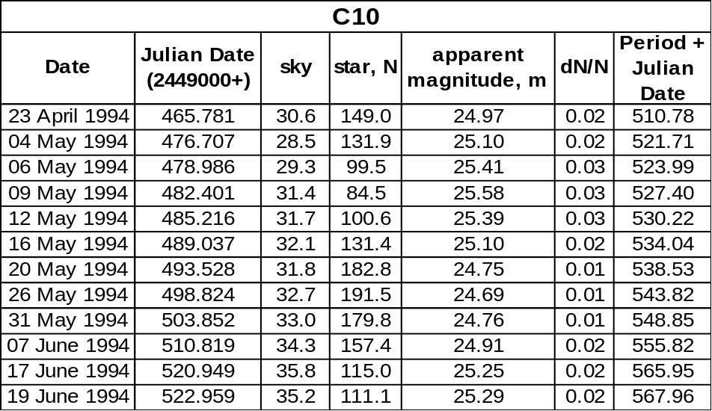

Mean star count = 136.21
Mean apparent magnitude = 25.06m

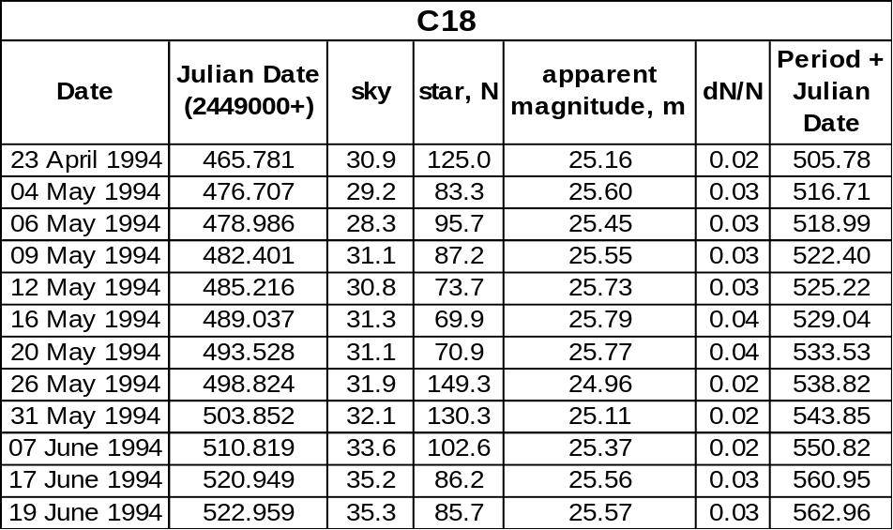

Mean star count = 96.65
Mean apparent magnitude = 25.44m

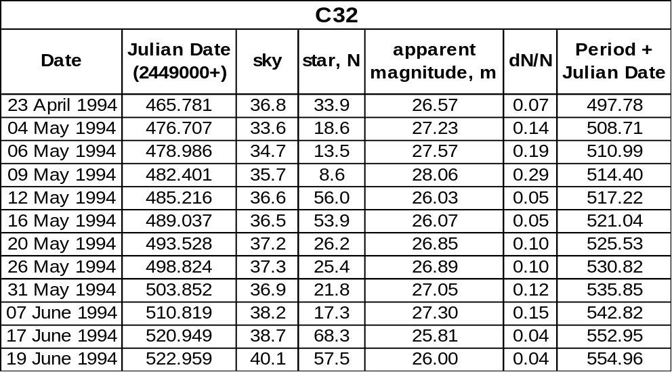

Mean star count = 33.42
Mean apparent magnitude = 26.59m

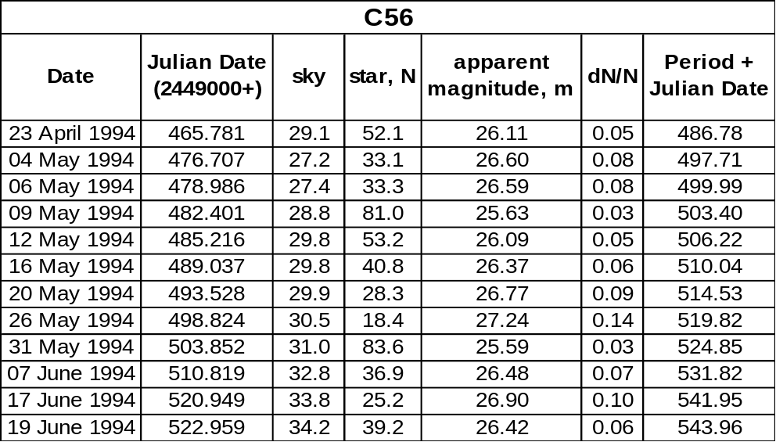

Mean star count = 43.76
Mean apparent magnitude = 26.30m

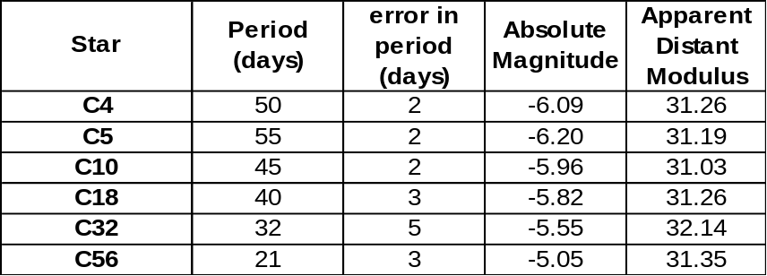

Mean apparent distance modulus = 31.37
Error in apparent distance modulus = ± 0.16

True distance modulus = 31.07
Distance to M100 = 1.64 x 10⁷ pc = 16.4 Mpc
Hubble constant H_{o} = 85.24 kms⁻¹Mpc⁻¹

Error in true distance modulus = ± 0.17
Error in distance to M100 = ± 0.129 x 10⁷ pc = ± 1.29 Mpc
Error in Hubble constant H_{o} = ± 8.93 kms⁻¹Mpc⁻¹

